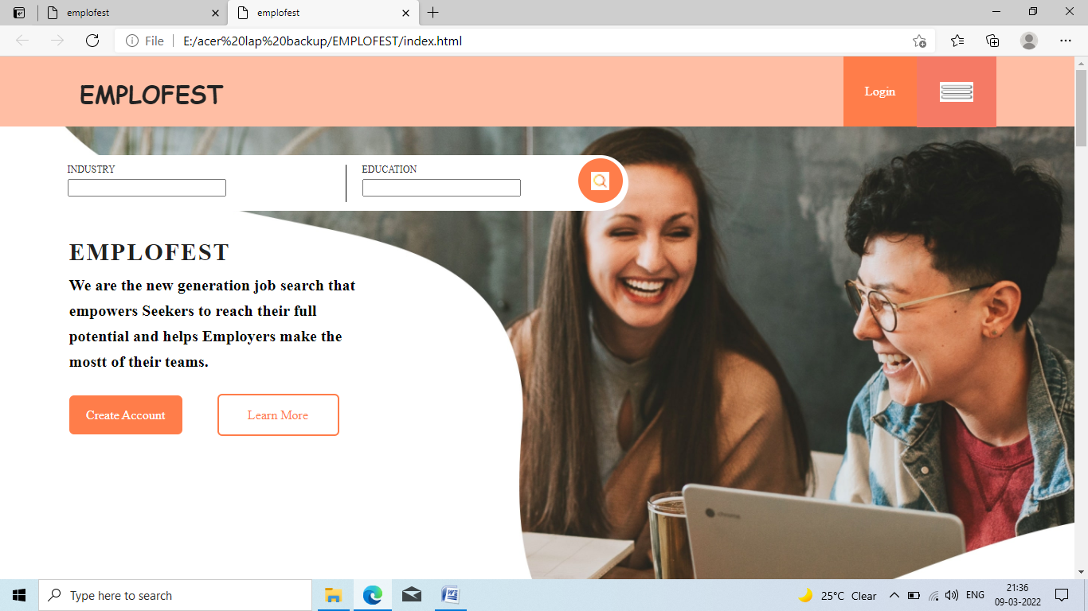

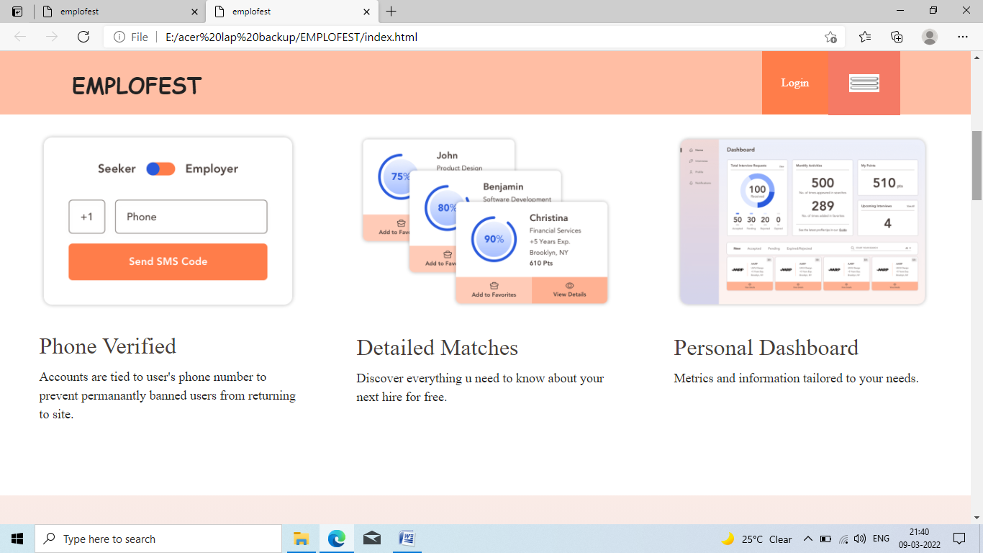

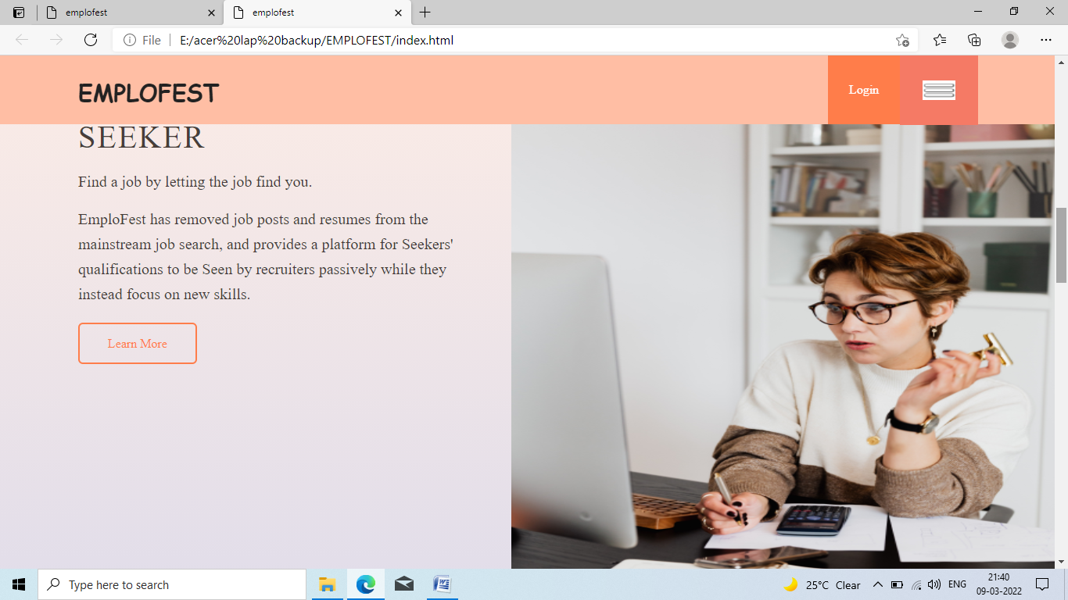

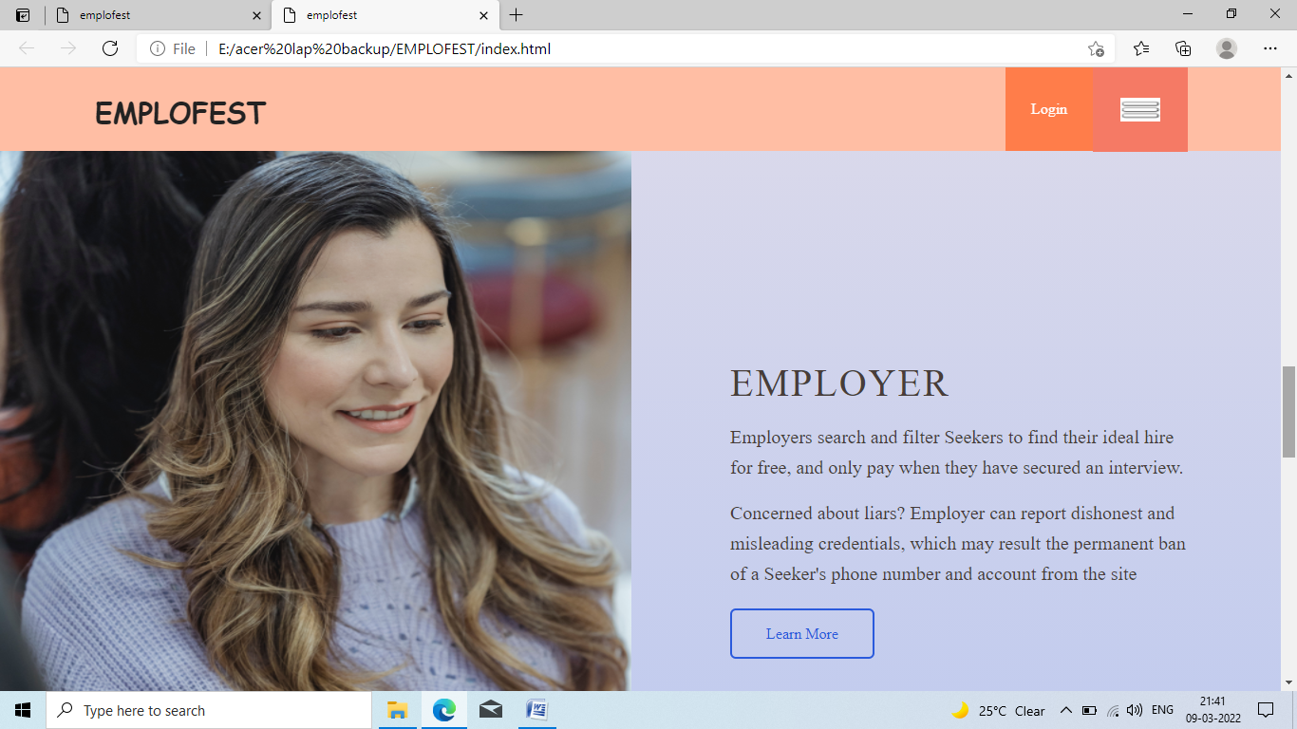

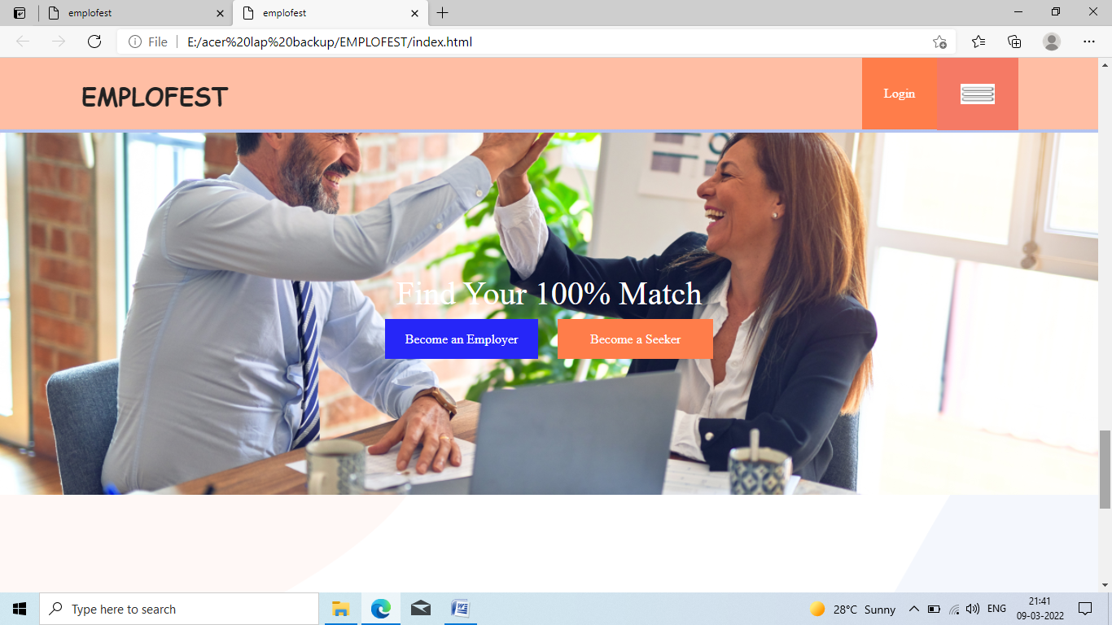

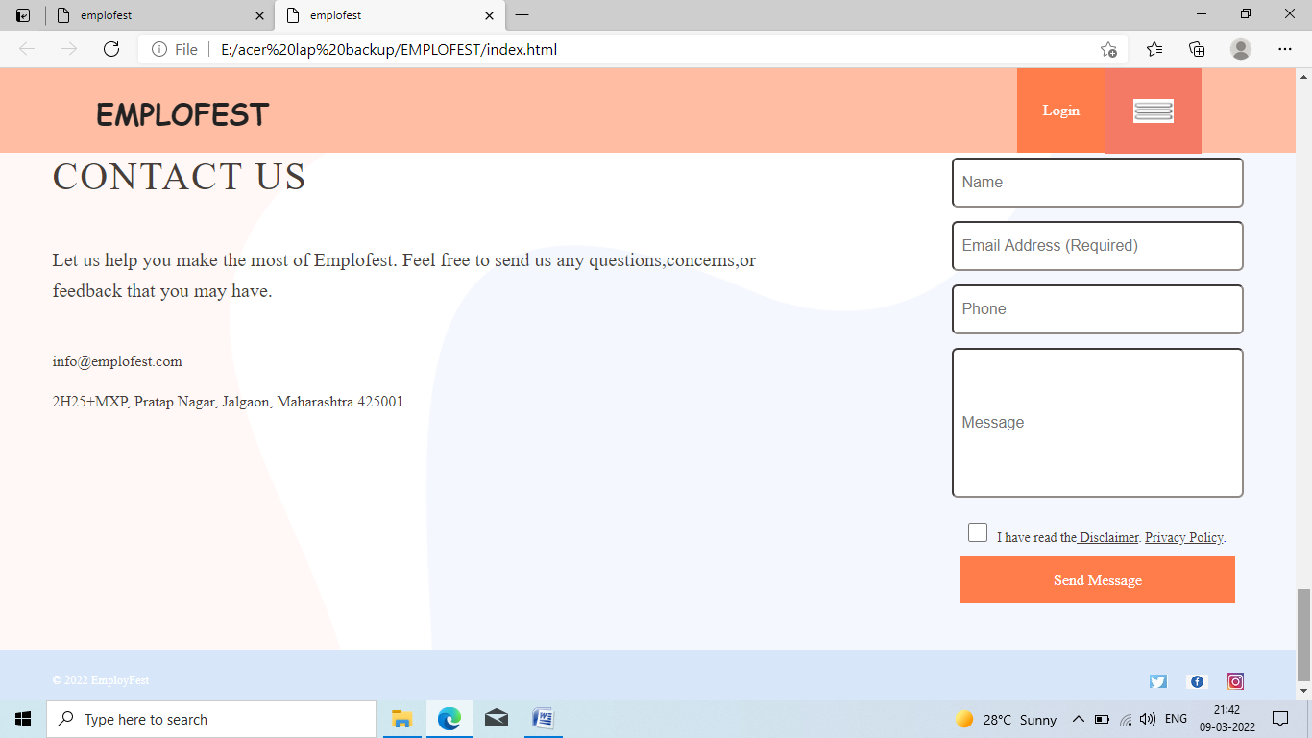

<!DOCTYPE html>

<html lang="en">

<head>

    <meta charset="UTF-8">

    <meta http-equiv="X-UA-Compatible" content="IE=edge">

    <meta name="viewport" content="width=device-width, initial-scale=1.0">

    <title>emplofest</title>

    <link href="../EMPLOFEST/style.css" rel="stylesheet">

</head>

<body>

    <header>

        <div class="header-wrap">

            <div class="logo">

               <h1>EMPLOFEST</h1>

            </div>

            <nav>

                <ul>

                    <li>

                        <a href="#" class="login">Login</a>

                    </li>

                    <li>

                        <a href="#" class="hamb"><img src="../EMPLOFEST/src/img/download-hamb.png"></a>

                    </li>

                </ul>

            </nav>

        </div>

    </header>

    <section class="container first-wrap">

        <div class="first-wrap-container">

            <div class="top-landing">

                <div class="t-l-l">

                    <h6>INDUSTRY</h6>

                    <input type="text" id="industry" name="industry">

                </div>

                <div class="t-l-r">

                    <div class="

                    tlr-left">

                   <div class="dropdown">

                       <h6>EDUCATION</h6>

                       <input type="text" id="education" name="education">

                   </div>

                    </div>

                </div>

                <div class="tlr-right">

                    <a href="#" class="search"><img src="../EMPLOFEST/src/img/images.png"></a>

                </div>

            </div>

            <div class="bottom-landing">

                <h1>EMPLOFEST</h1>

                <div class="bottom-landing-h5">

                    <h5>We are the new generation job search that empowers Seekers to reach their full potential and helps Employers make the mostt of their teams.</h5>

                </div>

                <div class="banner-btns">

                    <a href="#"><span class="create-account">Create Account</span></a>

                    <a href="#"><span class="learnmore">Learn More</span></a>

                </div>

            </div>

        </div>

    </section>

    <section class="container second-wrap">

        <div class="second-wrap-container">

            <div class="subdivs"><img src="src/img/below-banner-slide1-min.png">

                <h2>Phone Verified</h2>

                <h6>Accounts are tied to user's phone number to prevent permanantly banned users from returning to site.</h6>

            </div>

            <div class="subdivs"><img src="src/img/below-banner-slide2-min.png">

                <h2>Detailed Matches</h2>

                <h6>Discover everything u need to know about your next hire for free.</h6>

            </div>

            <div class="subdivs"><img src="src/img/below-banner-slide3-min.png">

                <h2>Personal Dashboard</h2>

                <h6>Metrics and information tailored to your needs.</h6>

            </div>

        </div>

    </section>

    <section class="container third-wrap">

        <div class="t-top">

            <div class="seeker-text">

                <h2>SEEKER</h2>

                <h5>Find a job by letting the job find you.</h5>

                <p>EmploFest has removed job posts and resumes from the mainstream job search, and provides a platform for Seekers' qualifications to be Seen by recruiters passively while they instead focus on new skills.</p>

                <a href="#" class="orange-btn"><span>Learn More</span></a>

            </div>

            <img class="seeker-pic" src="../EMPLOFEST/src/img/pexels-karolina-grabowska-4491444.jpg">

        </div>

        <div class="t-bottom">

            <img class="employer-pic" src="src/img/pexels-george-milton-6953965.jpg">

            <div class="employer-text">

                <h2>EMPLOYER</h2>

                <h5>Employers search and filter Seekers to find their ideal hire for free, and only pay when they have secured an interview.</h5>

                <p>Concerned about liars? Employer can report dishonest and misleading credentials, which may result the permanent ban of a Seeker's phone number and account from the site</p>

                <a href="#" class="blue-btn"><span>Learn More</span></a>

            </div>

        </div>

    </section>

    <section class="container fourth-wrap">

        <div class="fourth-wrap-div">

            <div class="f-w-d-h2">

                <h2>Find Your 100% Match<h2>

            </div>

            <div class="fourth-wrap-btns">

                <a href="#"><span class="employer-btn">Become an Employer</span></a>

                <a href="#"><span class="seeker-btn">Become a Seeker</span></a>

            </div>

        </div>

    </section>

    <section class="container fifth-wrap">

        <div class="fifth-wrap-container">

            <div class="contact_us">

                <h1>CONTACT US</h1>

                <p>Let us help you make the most of Emplofest. Feel free to send us any questions,concerns,or feedback that you may have.</p>

                <div class="address">

                    <a href="#" class="margin-btm">info@emplofest.com</a>

                    <a href="#"> 2H25+MXP, Pratap Nagar, Jalgaon, Maharashtra 425001</a>

                </div>

            </div>

            <div class="form">

                <input type="text" class="rad name" name="name" placeholder="  Name">

                <input type="text" class="rad email" name="email" placeholder="  Email Address (Required)">

                <input type="number" class="rad phone" name="phone" placeholder="  Phone">

                <input type="text" class="rad subject" name="Message" placeholder="  Message">

                <div class="checkboxdiv"><input type="checkbox" class="checkbox">

                    <h2>I have read the<a href="#"><span> Disclaimer</span></a>. <a href="#"><span> Privacy Policy</span>.</a></h2>

                </div>

                <a href="#"><span class="send-message">Send Message</span></a>

            </div>

        </div>

    </section>

    <section class="container sixth-wrap">

        <div class="sixth-wrap-container">

            <h6>© 2022 EmployFest</h6>

            <div class="social-icons">

                <a href="#"><img src="src/img/download (1).jpg"></a>

                <a href="#"><img src="src/img/download.png"></a>

                <a href="#"><img src="../EMPLOFEST/src/img/insta.jfif"></a>

            </div>

        </div>

    </section>

</body>

</html>

* {

    margin: 0;

    padding: 0;

    box-sizing: border-box;

    text-decoration: none;

    list-style: none;

}

body {

    -webkit-overflow-scrolling: touch;

    -webkit-font-smoothing: antialiased;

    -moz-osx-font-smoothing: grayscale;

}

header {

    position: fixed;

    width: 100%;

    background: transparent;

    z-index: 2;

}

.header-wrap {

    display: flex;

    justify-content: space-between;

    margin: 0 auto;

    align-items: center;

    height: 88px;

    max-width: 100%;

    z-index: 6;

    background-color: #ffbea4;

}

.logo {

    width: 126px;

    height: 25px;

    margin-left: 100px;

}

.logo img {

    width: 100%;

}

nav {

    width: 192px;

    margin-right: 100px;

}

nav ul {

    width: 100%;

    display: flex;

    justify-content: space-between;

}

nav ul li {

    width: 50%;

    display: flex;

    justify-content: center;

    align-items: center;

}

.login {

    background: #ff7d4a;

    padding: 28px 27px 28px;

    color: white;

    font-size: 16px;

    line-height: 32px;

}

.hamb {

    background: rgb(245, 122, 101);

    padding: 33px 29px 32px;

}

.hamb img {

    width: 42px;

    height: 25px;

}

.header-wrap h1{

    font-weight:bold;

    font-family: cursive;

    font-size: 30px;

}

/*first-wrap*/

.container {

    width: 100%;

}

.first-wrap {

    background: url("./src/img/1st\ image...jpg");

    background-position: center;

    background-size: cover;

    background-repeat: no-repeat;

    height: 100vh;

    margin: 0 auto;

}

.first-wrap-container {

    max-width: 1240px;

    margin: 0 auto;

    padding-top: 104px;

    padding-bottom: 194px;

    height: 100%;

    display: flex;

    flex-direction: column;

    justify-content: space-between;

}

.top-landing {

    max-width: 734px;

    height: 70px;

    display: flex;

    padding: 12px 7px 11px 30px;

    border-radius: 35px;

    background: white;

    position: relative;

    margin-bottom: 20px;

    margin-top: 20px;

}

.t-l-l {

    border-right: 1px solid black;

    display: flex;

    flex-direction: column;

    padding-right: 150.5px;

}

.t-l-m {

    border-right: 1px solid black;

    display: flex;

    flex-direction: column;

    padding-right: 80.5px;

    padding-left: 19.5px;

}

.t-l-r {

    display: flex;

    padding-left: 19.5px;

    justify-content: space-between;

}

.tlr-left {

    display: flex;

    flex-direction: column;

    margin-right: 67px;

}

.tlr-right {

    background: #ff7d4a;

    border-radius: 50%;

    width: 56px;

    height: 56px;

    display: flex;

    justify-content: center;

    align-items: center;

    position: absolute;

    top: 4px;

    right: 7px;

}

.top-landing h6 {

    font-size: 12px;

    margin-bottom: 6px;

    font-weight: 400;

}

.top-landing h4 {

    font-size: 18px;

    font-weight: 300;

}

.search img {

    height: 23px;

    width: 23px;

}

.bottom-landing {

    margin-left: 32px;

    max-width: 391px;

}

.bottom-landing h1 {

    font-size: 30px;

    letter-spacing: 2px;

    font-family: 'Times New Roman', Times, serif;

    font-weight: 900;

}

.bottom-landing-h5 {

    padding-top: 10px;

}

.bottom-landing h5 {

    font-size: 20px;

    line-height: 32px;

    color:#000;

    font-weight: 550;

}

.banner-btns {

    padding-top: 40px;

}

.create-account {

    width: 160px;

    height: 56px;

    background: #ff7d4a;

    color: white;

    font-size: 16px;

    line-height: 24px;

    padding: 16px 21.5px;

    border-radius: 6px;

    margin-right: 40px;

}

.learnmore {

    width: 160px;

    height: 56px;

    border: 2px solid #ff7d4a;

    color: #ff7d4a;

    font-size: 16px;

    line-height: 24px;

    background: white;

    padding: 16px 36.5px;

    border-radius: 6px;

}

/*second*/

.second-wrap-container {

    max-width: 1240px;

    margin: 0 auto;

    display: flex;

    justify-content: space-between;

    margin-top: 100px;

    margin-bottom: 100px;

}

.subdivs {

    width: 28.87%;

}

.subdivs img {

    width: 100%;

}

.subdivs h2 {

    font-size: 32px;

    line-height: 40px;

    margin-top: 31px;

    margin-bottom: 10px;

    color: #483d39;

}

.subdivs h6 {

    font-size: 18px;

    line-height: 26px;

}

/*Third*/

.third-wrap {

    background: linear-gradient(to bottom, #faebe6, #b3c3f0);

    padding-top: 43px;

    padding-bottom: 125px;

}

.t-top {

    max-width: 100%;

    height: 792px;

    display: flex;

    justify-content: space-between;

    position: relative;

}

.seeker-pic {

    width: 695px;

    height: 700px;

    position: absolute;

    right: 0;

    top: 0;

}

.seeker-text {

    padding-left: 100px;

    width: 580px;

}

.employer-text {

    width: 580px;

    padding-right: 100px;

    padding-top: 257px;

}

.employer-text h2 {

    font-size: 40px;

    letter-spacing: 2px;

    color: #483d39;

}

.employer-text h5 {

    font-size: 20px;

    line-height: 32px;

    color: #483d39;

    margin-top: 20px;

    margin-bottom: 16px;

}

.employer-text p {

    font-size: 20px;

    line-height: 32px;

    color: #483d39;

    margin-bottom: 40px;

}

.employer-text span {

    padding: 16px 36px;

    border: solid 2px #2a5adc;

    color: #2a5adc;

    border-radius: 6px;

}

.t-bottom {

    max-width: 100%;

    display: flex;

    justify-content: space-between;

    position: relative;

}

.employer-pic {

    width: 665px;

    height: 890px;

    top: -126;

    left: 0;

}

.seeker-text h2 {

    font-size: 40px;

    letter-spacing: 2px;

    color: #483d39;

}

.seeker-text h5 {

    font-size: 20px;

    line-height: 32px;

    color: #483d39;

    margin-top: 20px;

    margin-bottom: 16px;

}

.seeker-text p {

    font-size: 20px;

    line-height: 32px;

    color: #483d39;

    margin-bottom: 40px;

}

.seeker-text span {

    padding: 16px 36px;

    border-radius: 6px;

    border: solid 2px #ff7d4a;

    color: #ff7d4a;

}

/*fourth*/

.fourth-wrap {

    background: url("../EMPLOFEST/src/img/krakenimages-376KN_ISplE-unsplash.jpg");

    background-position: center;

    background-size: cover;

    background-repeat: no-repeat;

    height: 445px;

    display: flex;

    justify-content: center;

    align-items: center;

}

.fourth-wrap-div {

    width: 444px;

}

.f-w-d-h2 {

    margin-bottom: 24px;

    display: flex;

    justify-content: center;

    align-items: center;

}

.fourth-wrap-div h2 {

    font-size: 40px;

    color: white;

}

.fourth-wrap-btns {

    display: flex;

    justify-content: center;

    align-items: center;

}

.employer-btn {

    font-size: 16px;

    line-height: 24px;

    color: white;

    background: rgb(38, 38, 248);

    padding: 16px 25px;

    margin-right: 24px;

}

.seeker-btn {

    font-size: 16px;

    line-height: 24px;

    color: white;

    background: #ff7d4a;

    padding: 16px 40px;

}

/*fifth*/

.fifth-wrap {

    background: url("./src/img/contactus_background-min.png");

    background-position: center;

    background-size: cover;

    background-repeat: no-repeat;

}

.fifth-wrap-container {

    max-width: 1240px;

    margin: 0 auto;

    display: flex;

    justify-content: space-between;

    padding-top: 130px;

    padding-bottom: 64px;

}

.contact_us {

    flex: 1;

    max-width: 751px;

}

.contact_us h1 {

    color: #483d39;

    font-size: 40px;

    letter-spacing: 2px;

}

.contact_us p {

    color: #483d39;

    font-size: 20px;

    line-height: 32px;

    margin-top: 50px;

    margin-bottom: 50px;

}

.form {

    width: 304px;

    display: flex;

    flex-direction: column;

    align-items: center;

}

.address {

    display: flex;

    flex-direction: column;

}

.address a {

    font-size: 16px;

    color: #483d39;

}

.address .margin-btm {

    margin-bottom: 26px;

}

.address img {

    height: 23px;

    width: 20px;

    margin-right: 29px;

}

.rad {

    border-radius: 6px;

    border-color: #918b88;

}

.subject {

    width: 100%;

    height: 156px;

    margin-top: 14px;

    margin-bottom: 26px;

}

.name {

    width: 100%;

    height: 52px;

}

.email {

    width: 100%;

    height: 52px;

    margin-top: 14px;

    margin-bottom: 14px;

}

.phone {

    width: 100%;

    height: 52px;

}

.checkbox {

    color: #ffbea4;

    width: 20px;

    height: 20px;

    margin-right: 10px;

}

.send-message {

    padding: 16px 97px 16px 98px;

    width: 100%;

    background: #ff7d4a;

    text-decoration: none;

    color: white;

}

.checkboxdiv h2 {

    font-size: 14px;

    line-height: 32px;

    color: #483d39;

}

.checkboxdiv span {

    text-decoration: underline;

    color: #483d39;

}

.checkboxdiv {

    display: flex;

    margin-bottom: 20px;

}

/*sixth*/

.sixth-wrap-container {

    max-width: 1240px;

    margin: 0 auto;

    display: flex;

    justify-content: space-between;

    padding-bottom: 24px;

    padding-top: 24px;

}

.sixth-wrap {

  background-color: #d7e6f8;

}

.social-icons {

    width: 98px;

    display: flex;

    justify-content: space-between;

}

.sixth-wrap h6 {

    font-size: 12px;

    line-height: 16px;

    letter-spacing: 0.2px;

    color: white;

}